Overview of the Blocks
- Each section in a Degree Works Audit is called a “block.”
o Each block header will contain a title for the Block and will also display specific course information for that block such as credits applied and classes applied.

- The first block gives you to is the Student View which gives information about the student (A#, Major, GPA, Advisor)

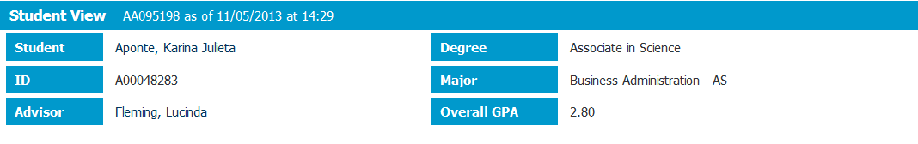

Degree Progress Status Bar
o This shows a student’s progress towards degree completion.

Legend
o The legend shows all symbols that are used throughout the Audit and what they represent. For example an asterisk (*) means there is a prerequisite for the course. If you click on the course you will see what the prerequisite is.

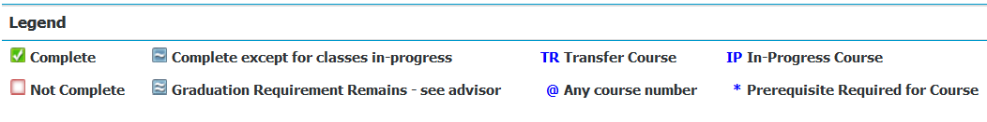

- Placement Test Results Block is located on the bottom of the Audit Sheet.

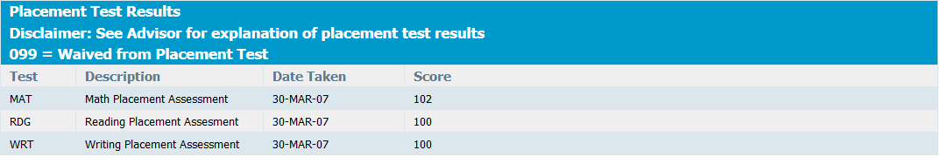

Degree in AA, AS, AAS or CERT Block
- This block shows the titles of the rest of the blocks that are used in the Degree Audit and it shows if the block requirement has been met or not.
- It also shows the total number of credits for the degree as well as how many credits are completed and how many credits are still needed.
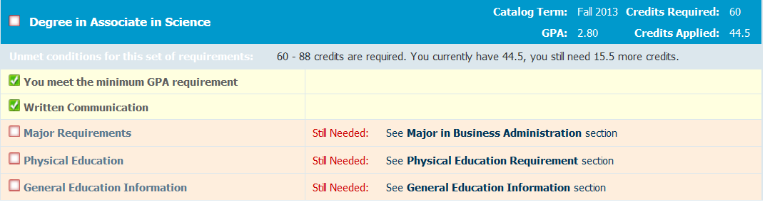

- The Written Communication will be in every Audit and P.E when applicable

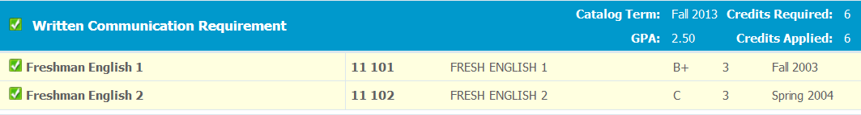

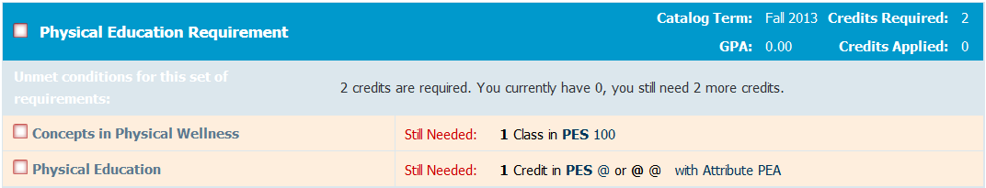

The remaining Blocks will always be specific to the student’s degree program. For example if they are Business Admin – AS their Major in Business Administration block will look like this:

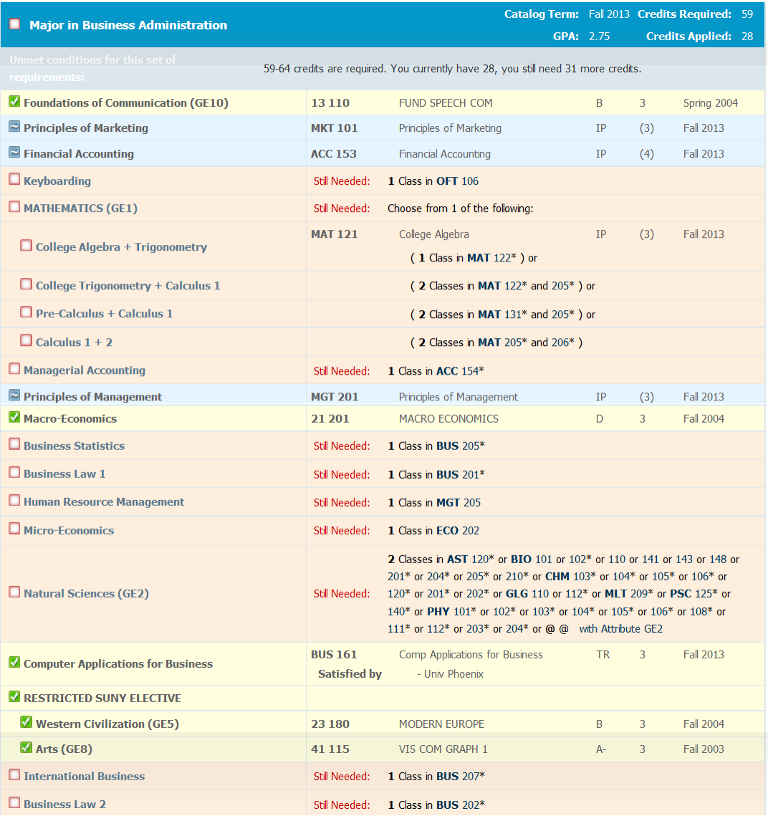

General Education Information Block
- This block shows a student’s progress through Gen Ed requirements. It is informational use only and it is only used for AS and AA degrees. So you will see course requirements which have already been met in the degree requirements above also listed as satisfying the Gen Ed requirements. This is generally a useful tool for students who are planning to transfer to another SUNY

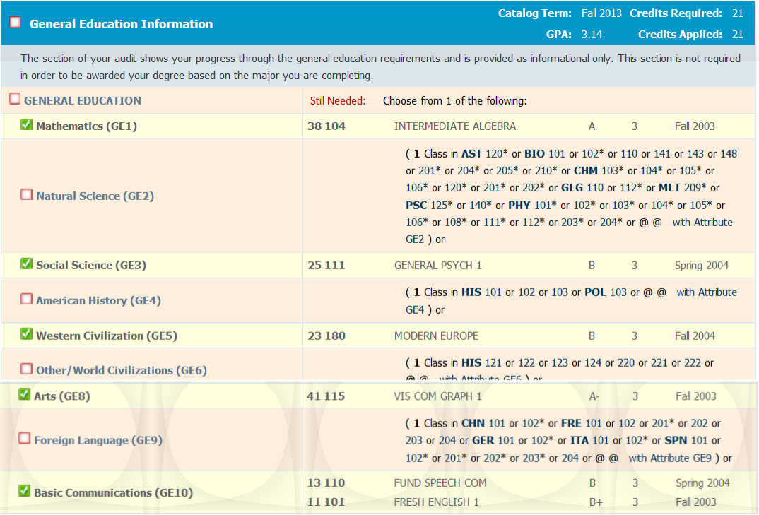

Fallthrough Courses Block

- These are courses which a student has passed and are not applicable to their current major

Insufficient Block

- This block shows courses which a student did not successfully complete

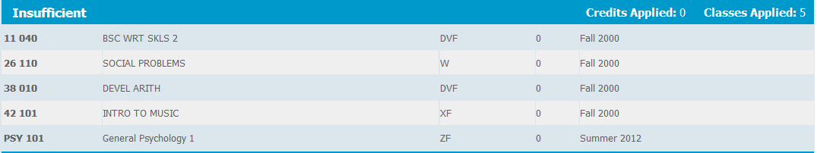

Not Counted Block

- This block shows any courses not counted toward degree. (example are developmental courses)

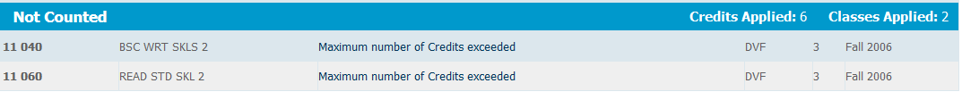

In-Progress Block

- This block shows course work currently in progress

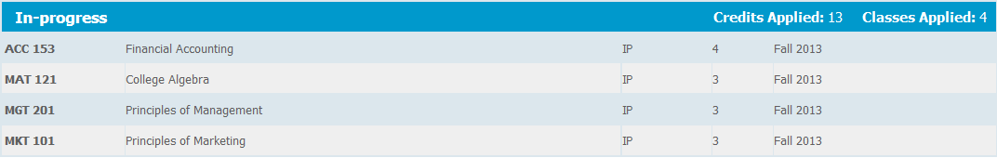

A “What If” analysis can be used if a student is planning on changing their program. The “What If” audit can be found under the Worksheets tab, on the left menu. It is designed to offer students an opportunity to view how proposed changes can affect their path towards graduation.

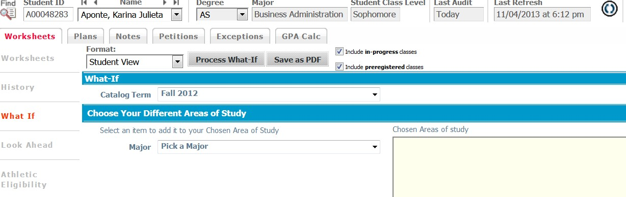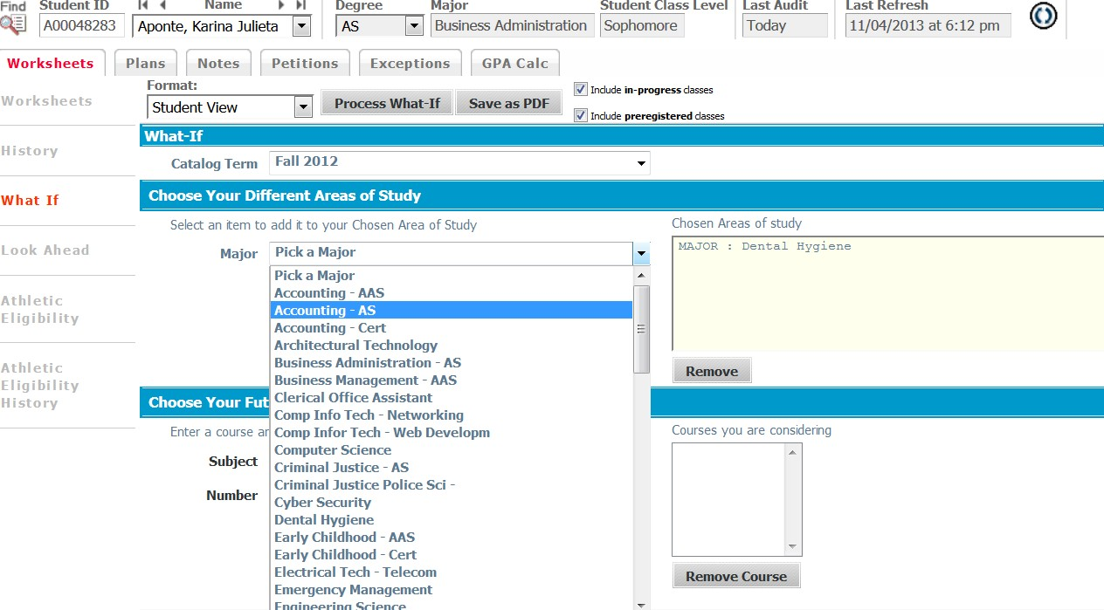

- Click “Process What If” Tab to see the results

- Click on Save as PDF 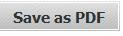 to save/print the “What If” Audit.

- For students with a catalog term prior to Fall 2010 they will get a message which states that Degree Works is not available for their catalog term and will be instructed to do a What-If Analysis and to check their specific catalog term if there may have been changes to their program of study.

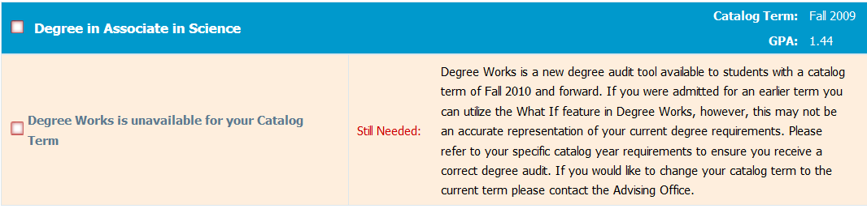

Notes

  - Notes are pre-defined by Advisors and are put in the degree audit.
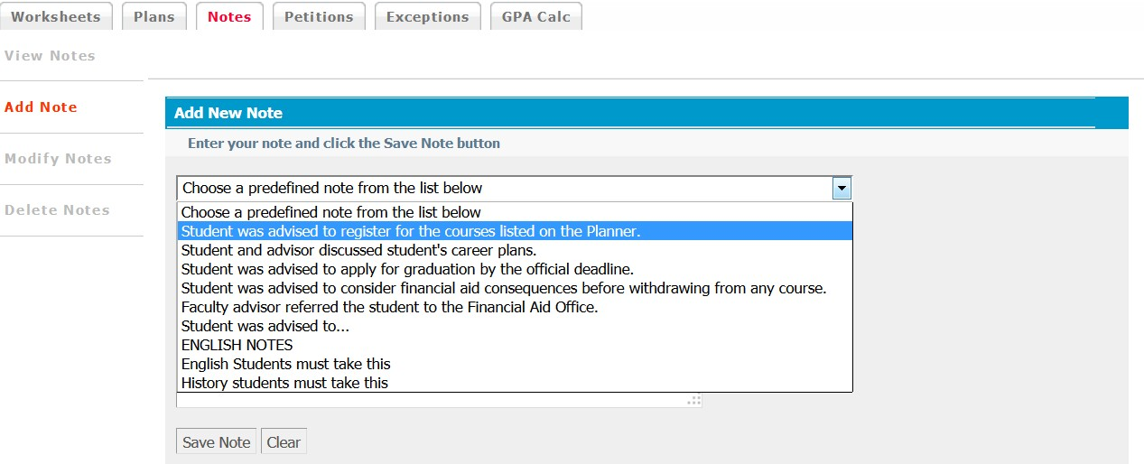

GPA Calculator

  - There are three different GPA calculators available in Degree Works: Graduation, Term and Advice calculators. The calculators, in conjunction with current Degree Works functions, can help students in many ways.

Graduation Calculator

  - This calculator takes the most “unknown” inputs. Many students may not know how many credits are required for their degree nor the number of credits remaining.
    - Credits remaining can be determined by subtracting credits required from credits applied. This information can be found on your degree audit (Worksheet Tab) in the first information block and is labeled as "Unmet conditions for this set of requirements.”

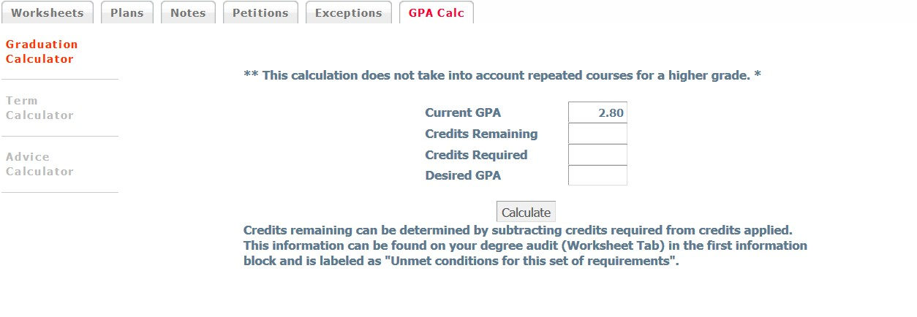

Term Calculator

  - This is the most specific calculator. It can be used for goal setting as well as mapping paths to avoid probation, achieve honors, etc.
    - The student’s current classes and credits (if applicable) are pre-loaded into the form. When done entering class information with expected grades, select calculate. The following screen will produce the new calculated GPA.

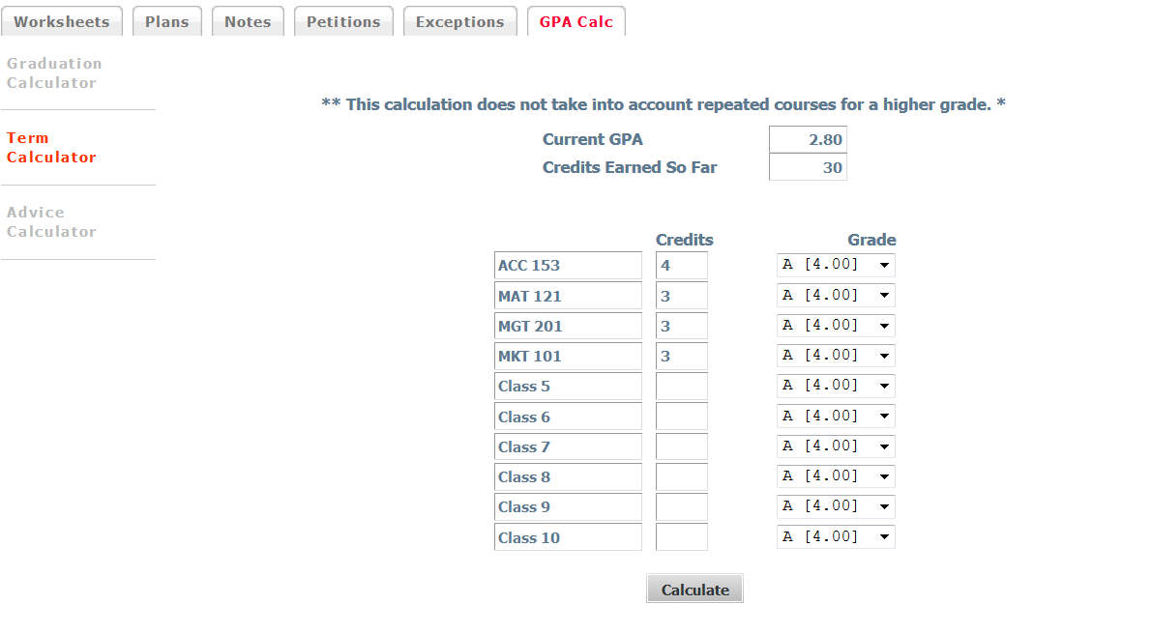

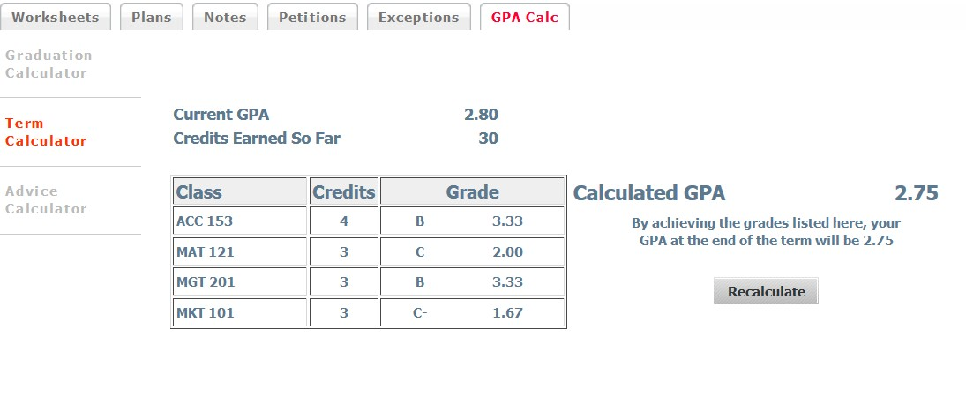

Advice Calculator

  - This calculator is used for students to input their desired GPA. It is used to figure how a student can raise their GPA with giving specific grades for advice.
    - It is also a realistic tool that will let students know if their desired GPA is not attainable.

