A “What If” analysis can be used if a student is planning on changing their program. The “What If” audit can be found under the Worksheets tab, on the left menu. It is designed to offer students an opportunity to view how proposed changes can affect their path towards graduation.

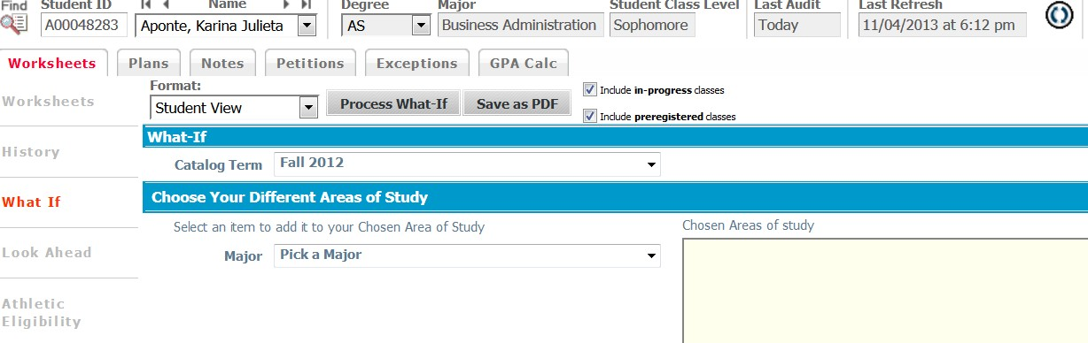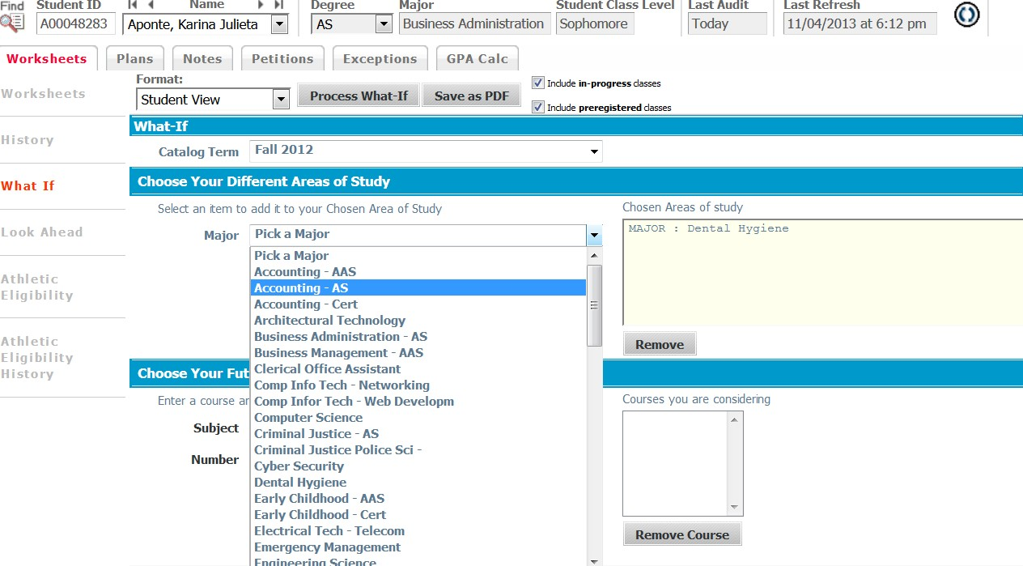

- Click “Process What If” Tab to see the results

- Click on Save as PDF 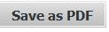 to save/print the “What If” Audit.

